The equivalence between markerless and marker-based motion capture for assessing overground gait

Sylvia Augustine ¹, Richard J. Foster ¹, Gabor Barton ¹, Mark Lake ¹, Raihana Sharir ² Jiaming Xu ³, Jos Vanrenterghem ³ and Mark A. Robinson ¹

¹ Research Institute for Sport and Exercise Sciences, Liverpool John Moores University,
Liverpool, United Kingdom
² Faculty of Sports Science and Recreation, Universiti Teknologi MARA (UiTM), Shah Alam, Selangor, Malaysia
³ Department of Rehabilitation Sciences, KU Leuven, Leuven, Belgium

s.b.augustine@2021.ljmu.ac.uk 0009-0006-0403-1439
r.j.foster@ljmu.ac.uk 0000-0003-2410-9839
g.j.barton@ljmu.ac.uk 0000-0002-7214-1967
m.j.lake@ljmu.ac.uk 0000-0003-2479-2551
raihanasharir@uitm.edu.my 0000-0002-5520-5367
jiaming.xu@kuleuven.be 0000-0002-1682-8430
jos.vanrenterghem@kuleuven.be 0000-0002-1682-8430
m.a.robinson@ljmu.ac.uk 0000-0002-5627-492X

Submission to XXXX

Introduction
Multi-camera markerless motion capture systems, such as Theia3D, have been increasingly used for the assessment of human movement and have been evaluated against established marker-based approaches across a growing body of validation literature. Previous validation studies comparing markerless and marker-based motion capture during gait have demonstrated that markerless systems can reproduce overall gait kinematic patterns, although systematic differences between approaches have been consistently reported (Kanko et al., 2021; Wishaupt et al., 2024; Kearney et al., 2025). Agreement is generally strongest for sagittal-plane kinematics, particularly knee flexion/extension, whereas systematic offsets have been observed for pelvic tilt, hip flexion/extension and ankle dorsiflexion/plantarflexion (Kanko et al., 2021; Wishaupt et al., 2024).For example, Kearney et al. (2025) reported an underestimation of anterior pelvic tilt using markerless motion capture, while Kanko et al. (2021) observed close agreement for knee flexion throughout the gait cycle. Agreement in the frontal plane is generally good for hip and knee ab/adduction, although phase-specific differences have also been reported (Greaves et al., 2025; Kearney et al., 2025). The largest discrepancies have typically been observed in the transverse plane, with hip and knee rotation and foot progression angles showing greater between-system differences and wider limits of agreement than sagittal-plane measures, with differences exceeding 10° for some variables and populations(Wishaupt et al., 2024; Kearney et al., 2025). Collectively, these findings indicate that although markerless and marker-based approaches reproduce similar overall gait patterns, systematic differences remain for specific kinematic variables, particularly pelvic tilt, rotational kinematics and foot progression angle.
The interpretation of these between-system differences depends not only on whether a difference is present, but also on whether its magnitude is sufficiently large to affect the interpretation of gait kinematics. In clinical gait analysis, clinically meaningful thresholds have been used to contextualise the magnitude of kinematic differences in relation to measurement error and their potential implications for clinical interpretation (McGinley et al., 2009; D’Souza et al., 2024; Kearney et al., 2025). For example, McGinley et al. (2009) proposed that measurement errors below 2° are generally unlikely to affect clinical interpretation, whereas errors between 2° and 5° may require consideration and those exceeding 5° may be sufficiently large to influence interpretation. This framework has been widely adopted, with several markerless validation studies interpreting between-system differences against a 5° criterion(D’Souza et al., 2024; Wishaupt et al., 2024; Greaves et al., 2025). However, such thresholds provide general benchmarks for interpreting measurement error rather than system-specific estimates of the smallest change that can be distinguished from measurement variability, and their use as arbitrary absolute cutoffs has been questioned given that the marker-based reference itself exhibits errors of comparable magnitude (Horsak et al., 2026). This distinction is important when determining whether two measurement approaches can be considered practically interchangeable. The minimal detectable change (MDC), derived from the standard error of measurement, provides an alternative, system-specific threshold by quantifying the magnitude of change required to exceed expected measurement error (Horsak et al., 2026). Consequently, evaluating between-system differences relative to the MDC of the markerless system may provide a measurement-based criterion for determining whether disagreement between markerless and marker-based approaches is sufficiently small relative to the measurement capability of the markerless system. Therefore, using the MDC of the markerless system as an equivalence bound provides a measurement-based criterion against which the magnitude of disagreement between markerless and marker-based systems can be evaluated. Equivalence testing provides a statistical framework for this comparison by determining whether the confidence interval around the between-system difference lies entirely within these prespecified bounds (Dixon et al., 2018; Lakens et al., 2018; O’Brien, 2021).
This approach differs conceptually from conventional hypothesis tests designed to detect differences between measurement systems. A non-significant difference does not provide evidence that two methods are sufficiently similar, as failure to detect a difference may reflect limited statistical power rather than meaningful agreement. Equivalence testing instead directly evaluates whether the magnitude of the between-system difference is sufficiently small to fall within prespecified acceptable bounds (Dixon et al., 2018). Applying the MDC of the markerless system as these bounds therefore allows equivalence to be interpreted relative to the measurement capability of the system: where between-system differences and their associated confidence intervals fall within the MDC, the disagreement is smaller than the magnitude of change required to exceed expected measurement error in the markerless system.
The aim of this study was to determine whether overground gait kinematics derived from markerless (ML) and marker-based (MB) motion capture systems are equivalent, by evaluating whether the magnitude of differences between systems falls below the minimal detectable change (MDC) of the ML system, which would indicate practical interchangeability.

Method
Participants
Twenty-four healthy adults (9 females, 15 males; mean ± SD age: 26 ± 5 years; height: 167 ± 8 cm; body mass: 67 ± 11 kg; body mass index: 24 ± 3 kg/m²) volunteered to participate in this study. Participants reported no history of lower-limb injury, were not undergoing rehabilitation, and had no diagnosed neuromuscular or musculoskeletal impairments at the time of testing. All participants provided written informed consent prior to data collection. Ethical approval was granted by the Liverpool John Moores University Research Ethics Committee.
Experimental protocol
Participants attended the laboratory for a single overground walking data collection session. Prior to testing, participants were instructed to wear tight-fitting clothing, consisting of base layers or a tight-fitting top exposing the elbows and tight shorts worn above the knee. This clothing was required to allow accurate placement and visibility of reflective markers for the marker-based motion capture system while also enabling reliable pose estimation from the markerless system. Participants were advised to wear contrasting colours between the top and shorts to facilitate markerless pose estimation. Markerless (ML) and marker-based (MB) motion capture data were recorded simultaneously during the trials. Eight overground walking trials were recorded for each participant along 10 m walkway at a self-selected walking speed. Eight separate walking trials were collected so each analysed gait cycle represented an independent walking attempt, consistent with a typical gait analysis procedure. Only the central right gait cycle from each walking trial was analysed to avoid analysing gait initiation and to make sure the participants appeared as a consistent size in all video cameras.

Tools and equipment
Motion capture data were collected using a combined marker-based and markerless setup consisting of ten Qualisys Arqus A12 infrared cameras and eight synchronised Qualisys Miqus video cameras (Qualisys AB, Gothenburg, Sweden). Video data were captured at a resolution of 1,920 × 1,080 pixels, while marker data were recorded at a sampling frequency of 85 Hz.
For the markerless setup, video cameras were mounted on tripods at heights between 1.2 and 1.65 m and positioned symmetrically around the capture volume. Cameras were placed closer to the centre of the volume than is typical for marker-based motion capture to ensure that participants were at least 500 pixels tall in each video frame near the centre of the walkway. For the marker-based setup, infrared cameras were mounted on the surrounding laboratory walls at a height of approximately 3 m and oriented towards the centre of the capture volume. Four additional spotlights were positioned around the capture volume to enhance lighting conditions and improve video brightness for markerless tracking. Both systems were calibrated simultaneously prior to data collection and shared the same global reference frame.
For the marker-based condition, 34 passive retroreflective markers (Figure 1) were placed on key anatomical landmarks of the pelvis, thigh, shank and foot according to the Conventional Gait Model (CGM) version 1.1 and CGM 2.4 (Leboeuf et al., 2019). The pelvis was defined by markers placed on the left and right anterior and posterior superior iliac spines. These landmarks define the pelvic coordinate system and give the reference segments for hip joint kinematics. Thigh segments were defined with marker placed on the lateral femoral epicondyle and additional tracking marker on the lateral aspect of the thigh. The shank segment was defined using a marker on the lateral malleolus and a tracking marker on the lateral side of the shank. The foot segment was defined using markers placed on the posterior calcaneus, second metatarsal head, and fifth metatarsal head. Medial knee and ankle markers were recorded during the static calibration trial to determine knee and ankle joint widths, which were used to estimate joint centres within the biomechanical model. The virtual foot was implemented based on the foot model of CGM2.4 [ref]. Due to the differences in the shoe structure and marker placement constraints the heel markers were positioned at a different height to the second metatarsal markers, thus to reduce the artificial offset created, a virtual landmark was generated in Visual3D (C-Motion Inc., Germantown, MD, USA) to offset the landmark in the vertical (Z) direction to align with the second metatarsal marker height. This landmark was then subsequently used for ankle kinematic calculations.

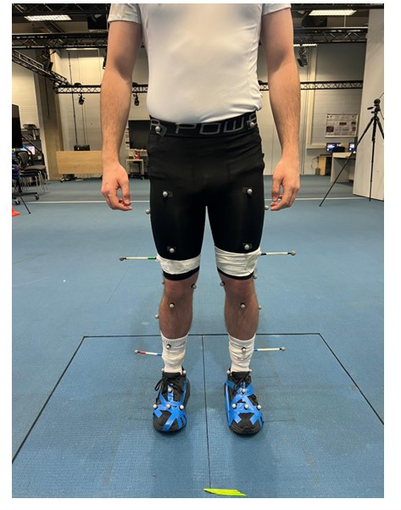
Figure 1 Examples of lower-limb reflective marker placement for motion capture data collection

Data processing and analysis
Marker-based
Marker trajectories were labelled and tracked using Qualisys Track Manager (version 2025.2; Qualisys AB, Gothenburg, Sweden). The three-dimensional marker-based kinematic data were filtered using a low-pass fourth-order Butterworth filter with a cut-off frequency of 6 Hz.
Processed marker trajectories were imported into Visual3D (version 2024.10.4; C-Motion Inc., Germantown, MD, USA), where a biomechanical model was applied to calculate joint kinematics. Heel strike and toe-off gait events were identified using the method described by Zeni et al. (2008), based on the maximal anterior–posterior displacement of the heel and toe relative to the sacrum.
Pelvis, hip, knee, ankle, and foot joint kinematics were calculated for a single right-sided gait cycle, defined from right heel strike to the subsequent right heel strike. Each gait cycle was linearly time-normalised to 101 data points and exported to MATLAB (R2022a; The MathWorks Inc., Natick, MA, USA) for further analysis.
Segment lengths of the tibia and femur were calculated in Visual3D as the vector distance between proximal and distal segment endpoints. As segment lengths remained constant within each trial, a single representative value was extracted per trial and averaged across the eight walking trials.
Markerless
Markerless video data were processed using Theia3D (version 2024.1.17; Theia Markerless Inc., Kingston, ON, Canada), which generated a full-body biomechanical model with six degrees of freedom at the pelvis and three rotational degrees of freedom at the hip, knee, and ankle joints. An independent inverse kinematics (IK) model was scaled automatically by Theia3D for each trial. Segment pose estimation produced 4 × 4 transformation matrices across all frames, which were smoothed using a low-pass generalised cross-validatory spline (GCVSPL) filter with a cut-off frequency of 20 Hz.
The processed markerless data were exported and imported into Visual3D (version 2024.10.4; C-Motion Inc., Germantown, MD, USA), where the same analysis pipeline as the marker-based data was applied. Heel strike and toe-off events were identified using the Zeni et al. (2008) method. Joint kinematics for the pelvis, hip, knee, ankle, and foot were calculated for a single right-sided gait cycle (right heel strike to subsequent right heel strike). Each gait cycle was time-normalised to 101 data points and exported to MATLAB (R2025a; The MathWorks Inc., Natick, MA, USA) for further analysis.

Statistical analysis
Means and standard deviations were calculated for each participant across the eight walking trials for both marker-based and markerless systems. These participant means were used to generate 1D 90% paired-samples confidence intervals across the gait cycle using the spm1d package [ref]. This approach uses a simultaneous random-field-theory-based confidence interval that maintains the family-wise error rate over an unknown set of nodes, thereby permitting judgements of equivalence at different regions of the gait cycle. Equivalence bounds were defined a-priori as the mean minimal detectable change (MDC) calculated over the gait cycle for each kinematic variable based on a previous markerless reliability study by Augustine et al. ((Augustine et al., 2025)). In that study, measurement error was estimated from the inter-session variation from tight-fitting clothing. The MDC was calculated as 1.96 × √2 times this error term representing the smallest detectable change beyond measurement error with 95% confidence. Defining equivalence bounds using the MDC ensures that the equivalence bounds reflect the inherent variability of the markerless system, so any differences between systems that fall within ±MDC are considered practically negligible, as they cannot be distinguished from within-system measurement error.
Confidence intervals and equivalence bounds were judged according to one of three outcomes: Equivalent, non-equivalent and inconclusive…… Equivalence was concluded when a confidence interval was fully within the equivalence bounds, non-equivalence was concluded when the entire confidence interval was fully beyond an equivalence bound nd inconclusive
Kinematic variables were considered equivalent where the 90% confidence interval of the between-system difference was entirely within the ±MDC equivalence bounds across the gait cycle (Figure 2). As no inter-session variation was available for foot progression this was assigned bounds of ±5˚.

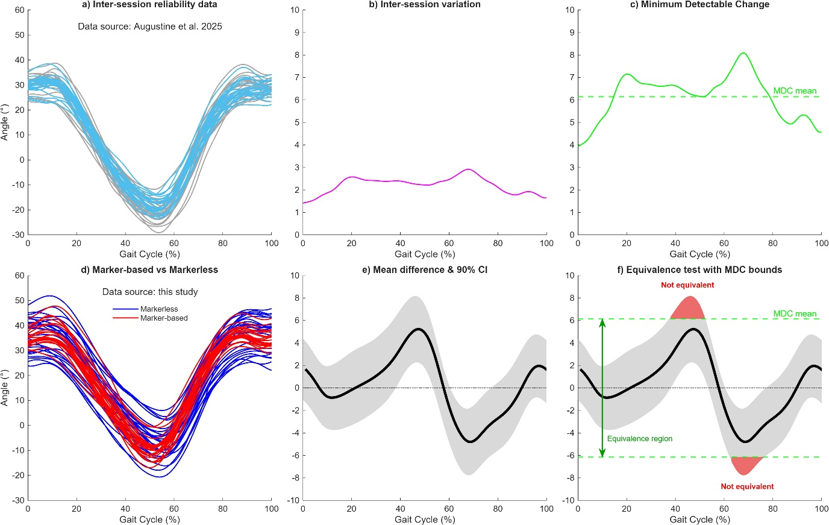
Figure 2. The process of defining equivalence based on measurement error derived from reliability data. (a) Mean hip joint kinematics from two sessions measurements (Augustine et al., 2025) were used to (b) calculate the inter-session variation, which was then used to (c) derive the Minimal Detectable Change (MDC). The average MDC was used to define the equivalence bounds (±°) for comparisons between marker-based (MB) and markerless (ML) systems. (d) In this study, mean hip joint kinematics were obtained for both systems, from which (e) the mean difference and 90% confidence interval (CI) were calculated. These confidence intervals were then compared against the MDC-derived bounds (f), with non-equivalence (red shaded area) concluded when the CI exceeded ±MDC equivalence bounds.

Results
Equivalence
Equivalence tests (Figure 3 and Table 1) indicated that the degree of agreement varied across kinematic variables. High equivalence was observed for pelvic rotation (93%), knee flexion (92%) and hip flexion (71%). Moderate equivalence was observed for ankle dorsiflexion (62%), hip rotation (59%), knee varus (57%), pelvis anterior tilt (47%) and pelvis obliquity (32%). Lower equivalence was observed for hip adduction (20%), ankle inversion (9%) and ankle rotation (9%), and zero equivalence was observed for foot progression (0%).
Pelvis rotation and knee flexion showed the highest levels of equivalence, with 93% and 92% of the gait cycle, respectively, falling mostly within the predefined equivalence bounds. For pelvis rotation, equivalence was observed from 1-24% and 32-100% of the gait cycle, while for knee flexion it occurred from 1-60% and 69-100% of the gait cycle. Hip flexion also demonstrated high equivalence, with 71% of the gait cycle falling within the equivalence bounds. Equivalent regions were observed from 1-38% of the gait cycle, during pre-swing (54-63%), and during mid-to-terminal swing (78-100%).
Moderate levels of equivalence were observed for ankle dorsiflexion, hip rotation, knee varus, pelvis anterior tilt, and pelvis obliquity. Ankle dorsiflexion demonstrated equivalence across 62% of the gait cycle, occurring from 9-52% and 69-87%. Hip rotation showed equivalence for 59% of the gait cycle, with equivalent regions from 14-33% and 54-93%. Knee varus demonstrated 57% equivalence, occurring from 15-59%, 83-86%, and 89-97% of the gait cycle. Pelvis anterior tilt showed equivalence for 47% of the gait cycle (9-28% and 58-84%), while pelvis obliquity demonstrated the lowest equivalence within this group, with 32% of the gait cycle falling within the equivalence bounds (30-37% and 59-82%).
Hip adduction demonstrated limited equivalence, with 20% of the gait cycle falling within the predefined equivalence bounds (35–45% and 53–61%). Very low levels of equivalence were observed for ankle inversion and ankle rotation, each demonstrating equivalence for only 9% of the gait cycle, occurring at 81–89% and 15–23%, respectively. Finally, foot progression angle demonstrated consistent offsets between systems, resulting in 100% of CI exceeding the equivalence bounds across all of the gait cycle.

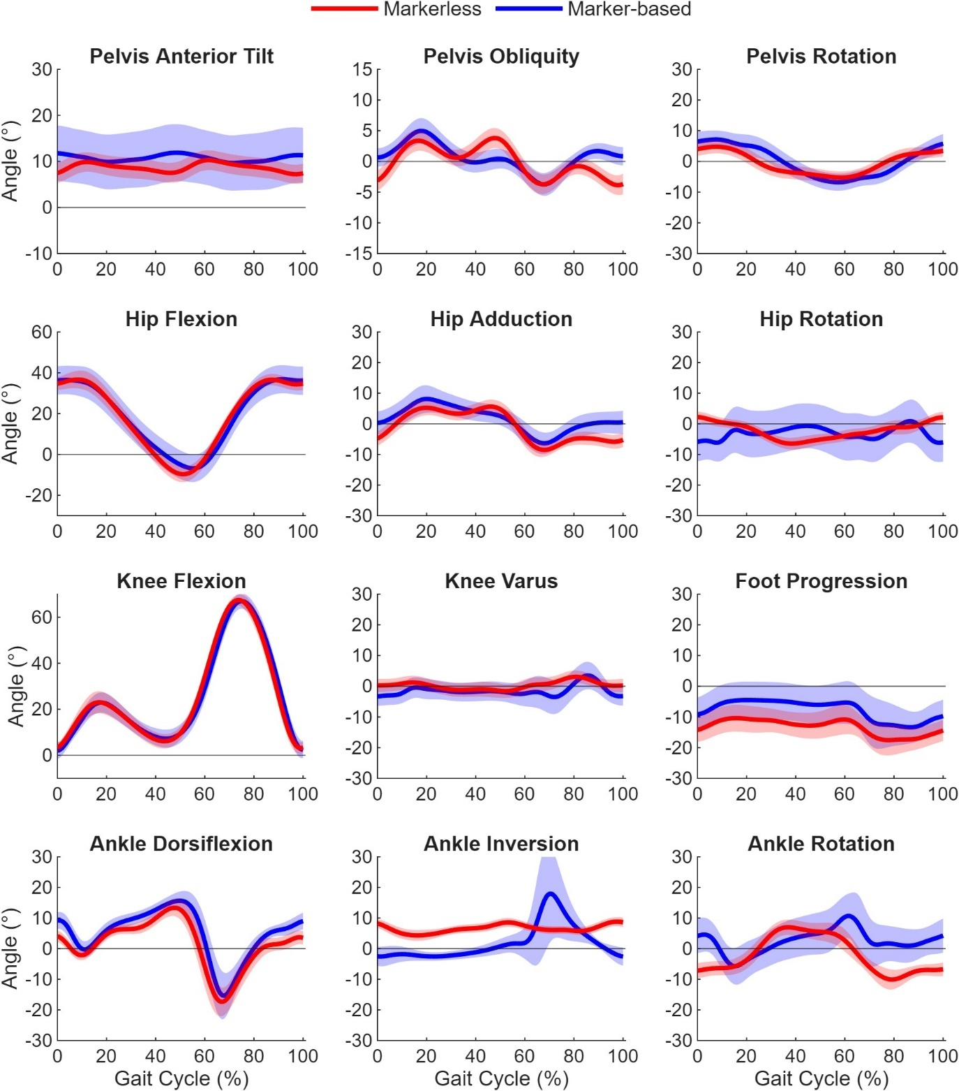

Figure 3. The grand mean ± standard deviation of marker based and markerless lower-limb kinematics. Subplot titles represent the positive direction of the signal.

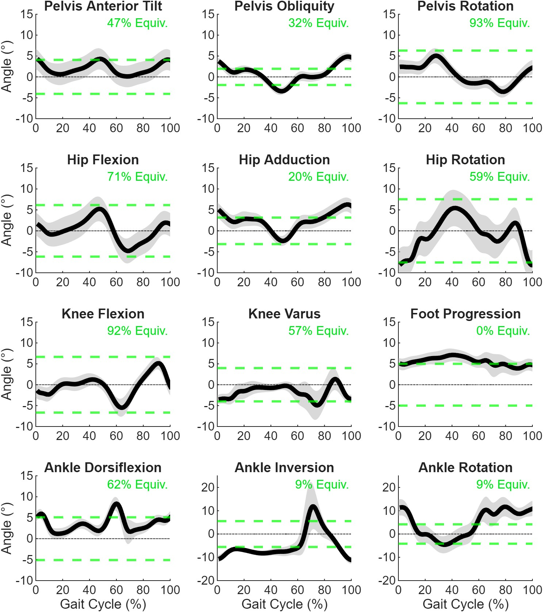

Figure 4. Equivalence test results for all kinematic variables. The mean between-system difference is plotted (black line) with the 90% confidence intervals (grey shaded area). Where the 90% confidence intervals exceed the ±MDC equivalence bounds (green dashed lines) this indicates that systems are not-equivalence at these periods of the gait cycle. The green percentage (inset upper right) quantifies the percentage of the gait cycle that within the equivalence bounds i.e. equivalent (equiv.). Subplot titles represent the positive direction of the signal.

Table 1. Equivalence testing results comparing marker-based (MB) and markerless (ML) kinematic waveforms across the gait cycle. MDC represents the minimum detectable change (MDC) equivalence bound (±°). The percentage indicates the proportion of the confidence interval (CI) that fell within the equivalence bounds across the gait cycle. Intervals indicate the regions of the gait cycle where the CI remained within the equivalence bounds. Joint variable titles represent the positive direction of the signal.
Joint variable | ±MDC (°) | Fully Equivalent | % Equivalence | Equivalent Gait Cycle Intervals (%)
Pelvis Rotation | 6.30 | No | 93 | 1–24; 32–100
Knee Flexion | 6.66 | No | 92 | 1–60; 69–100
Hip Flexion | 6.15 | No | 71 | 1–38; 54–63; 78–100
Ankle Dorsiflexion | 5.10 | No | 62 | 9–52; 69–87
Hip Rotation | 7.54 | No | 59 | 14–33; 54–93
Knee Varus | 3.99 | No | 57 | 15–59; 83–86; 89–97
Pelvis Anterior Tilt | 4.07 | No | 47 | 9–28; 58–84
Pelvis Obliquity | 1.94 | No | 32 | 30–37; 59–82
Hip Adduction | 3.16 | No | 20 | 35–45; 53–61
Ankle Inversion | 5.55 | No | 9 | 81–89
Ankle Rotation | 4.17 | No | 9 | 15–23
Foot Progression | 5.00 | No | 0 | –

**add horsak bench threshold- in discussion – comment on difference between ML and MB MDC in discussion

Discussion
The purpose of this study was to assess whether the Theia3D markerless system could provide equivalent kinematic results to those from marker-based motion capture in healthy adult gait. Visually, waveform comparisons demonstrated qualitative similarity between both systems across most joints and planes. Equivalence tests however identified that no waveforms were entirely equivalent throughout the gait cycle between systems, though some had substantial periods of equivalence. The equivalence between systems varied by joint and plane of motion, with the sagittal plane kinematics generally being more equivalent than the frontal and transverse planes.
Sagittal kinematics demonstrated the least variability and highest similarity between systems. Hip, knee and ankle showed highly consistent waveform shape and timing with high equivalence observed in the knee flexion (92%), hip flexion (71%) and ankle flexion (62%). This is likely due to the larger magnitude of flexion–extension movements during gait, reduced sensitivity to joint centre and axis definition errors, and the presence of strong visual cues that support robust pose estimation in markerless motion capture. This finding also aligns with previous comparisons of markerless and marker-based systems, which consistently report smaller differences in sagittal plane kinematics than in frontal or transverse planes.(Scataglini et al., 2024{Kanko, 2021 #2; Walker et al., 2025)} Non-equivalence regions in hip, knee, and ankle flexion occurred primarily during the swing phase which might be due to the nature of the walking as this is the most dynamic part of the gait cycle. During swing, joints move more rapidly and reach their peak flexion values, while the limb is unconstrained by ground contact. As a result, small differences between markerless and marker-based measurements become more noticeable and are more likely to exceed the predefined equivalence bounds, even when overall waveform similarity is high.
In contrast, the frontal and transverse plane kinematics were less equivalent. While hip abduction/adduction and knee varus/valgus showed generally similar waveform patterns, the equivalence was moderate to low for hip abduction/adduction and knee varus/valgus indicating that agreement was inconsistent along the gait cycle. Hip abduction/adduction showed greater variability that was observed in the MB data. Increased frontal plane variability in marker-based systems has been widely reported and is commonly attributed to sensitivity to marker placement and soft tissue artefact (Pinzone et al., 2014). In contrast, markerless systems may produce smoother frontal plane waveforms due to…….. The MB system demonstrated an increased knee varus “bump” during the swing phase, which may be due to crosstalk between sagittal and frontal plane kinematics which is commonly reported in gait studies (Wren et al., 2023; Greaves et al., 2025). For hip rotation the results showed notable variability in both systems, with wider variability observed in MB data. Even with updated model definitions and improved pelvis alignment in ML systems, hip rotation remains inherently different between systems due to the biomechanical and methodological challenges of capturing transverse plane kinematics. Previous literature has similarly reported that transverse plane kinematics are known to be challenging to measure accurately due to their small ranges of motion and high sensitivity to joint axis definition and pelvis orientation. These challenges affect both ML and MB systems and likely explain the persistent non-equivalence observed for hip rotation in this study, consistent with previous validity and reliability findings (Wade et al., 2022; Wren et al., 2023; Scataglini et al., 2024). The foot progression angle demonstrated consistent offsets between systems, resulting in non-equivalence throughout the entire gait cycle, likely due to differences in foot segment definition and reference frame alignment between ML and MB models.
Although pelvis waveforms were similar between systems, systematic differences in angle magnitude and increased variability were observed. Pelvic kinematics demonstrated strong agreement in pelvic rotation but weaker in pelvic tilt and obliquity. High equivalence was observed in pelvic rotation supporting the interchangeability of this variable. However pelvic tilt and obliquity showed increased variability and lower equivalence likely due to differences in pelvic segment definition and coordinate system alignment between markerless and marker-based models. Pelvic orientation is highly sensitive to the definition of anatomical reference frames, and even small differences in model assumptions can result in consistent offsets in reported angles (Kanko, 2020; Wren et al., 2023; Coll et al., 2024). Pelvic rotation has greater equivalence because it has a larger angle than in sagittal and frontal.
We believe this to be the first study to evaluate time-varying (1D) equivalence between marker-based and markerless systems. Equivalence is a useful perspective through which two measurement tools can be evaluated because it requires researchers to justify the thresholds of equivalence in an a-priori manner and there is a single objective result. These results showed that qualitative waveform similarity and low measurement variability do not necessarily imply equivalence between systems. Equivalence testing penalises both systematic bias and increased variability, making it particularly sensitive to small but consistent offsets between systems. In this study we used minimum detectable change (MDC)-based equivalence bounds rather than a single fixed threshold e.g. +/- 5 degrees as is commonly used in the gait analysis literature. This allowed the interpretation of equivalence to be tightly coupled to the measurement sensitivity of the markerless system; where if any discrepancy between the markerless and marker-based systems was within the MDC, it was be considered functionally negligible, supporting practical interchangeability. The equivalence bounds in this study were based on markerless measurement error. However, the marker-based comparator also has measurement error of its own. In a recent systematic review, Horsak et al. (2026) reported median inter-session SEMs for marker-based overground gait kinematics of 2.4°, 1.9° and 3.3° in the sagittal, frontal and transverse planes, respectively. They argued that agreement between a new technology and a marker-based reference cannot be expected to exceed the reference system’s own measurement error. Nevertheless, these equivalence bounds require careful consideration, our bounds were from a single laboratory environment, software version and clothing condition so may not be universally applicable.
Compared with the marker-based MDCs Horsak et al. (2026) reported for healthy adults, the markerless MDCs used here were similar for the sagittal plane. Values were within approximately 2° for hip flexion (6.2° vs 6.7°), knee flexion (6.7° vs 4.8°), ankle dorsiflexion (5.1° vs 4.4°) and pelvic tilt (4.1° vs 4.6°). In contrast, markerless MDCs were considerably smaller for most frontal and transverse plane variables, particularly hip rotation (7.5° vs 15.8°), ankle rotation (4.2° vs 11.9°) and knee varus/valgus (4.0° vs 8.3°). Pelvic rotation was the main exception, with a larger markerless MDC (6.3° vs 3.4°).
The lower inter-session error of the markerless system is consistent with the absence of marker replacement between sessions. Marker misplacement is a dominant source of between-session error in marker-based gait analysis, particularly for hip and knee rotation (Della Croce et al., 2005{Horsak, 2026 #163)}. However, a smaller MDC does not necessarily indicate greater accuracy. The lower markerless variability observed in the present study (Figure 3) may partly reflect model constraints and smoothing within the pose-estimation and inverse-kinematics pipeline, which may also reduce sensitivity to genuine stride-to-stride variation.
While markerless motion capture demonstrated generally comparable kinematic outputs to marker-based systems in healthy adults, differences attributable to model definitions and segment coordinate systems remain evident. These findings do not suggest that one system is inherently superior, but rather that ML and MB systems should be interpreted as distinct measurement approaches with different strengths and limitations.

Limitation of the study
Several limitations should be considered when interpreting the results of this study. Firstly, the relatively small sample of healthy adults may limit the generalisability of the equivalence findings to other populations or gait patterns. Additionally, the analysis focused on a single markerless system within the same laboratory and a specific marker-based model, and results may vary with different hardware, algorithms, or modelling approaches. Future research should investigate the performance of markerless motion capture in pathological gait populations, assess sensitivity to clinically meaningful changes over time, and explore methodological refinements to improve frontal and transverse plane accuracy.

Conclusion
In summary, markerless and marker-based motion capture systems showed greatest equivalence in pelvis rotation and sagittal plane kinematics, although agreement at the ankle was less consistent. While frontal and transverse plane demonstrated greater variability and lower equivalence. Although both systems produced similar overall gait patterns, no variables were fully equivalent, indicating that at this moment the systems are not fully interchangeable. These findings suggest that markerless motion capture maybe useful for assessing selected parameters of normal gait, but caution is needed especially for frontal and transverse planes.

References

Augustine, S., Foster, R., Barton, G., Lake, M.J., Sharir, R. and Robinson, M.A. (2025) The inter-trial and inter-session reliability of Theia3D-derived markerless gait analysis in tight versus loose clothing. PeerJ, 13, e18613.

Coll, I., Mavor, M.P., Karakolis, T., Graham, R.B. and Clouthier, A.L. (2024) Validation of Markerless Motion Capture for Soldier Movement Patterns Assessment Under Varying Body-Borne Loads. Annals of Biomedical Engineering.

D’Souza, S., Siebert, T. and Fohanno, V. (2024) A comparison of lower body gait kinematics and kinetics between Theia3D markerless and marker-based models in healthy subjects and clinical patients. Scientific reports, 14 (1), 29154.

Della Croce, U., Leardini, A., Chiari, L. and Cappozzo, A. (2005) Human movement analysis using stereophotogrammetry: Part 4: assessment of anatomical landmark misplacement and its effects on joint kinematics. Gait & Posture, 21 (2), 226-237.

Dixon, P.M., Saint-Maurice, P.F., Kim, Y., Hibbing, P., Bai, Y. and Welk, G.J. (2018) A primer on the use of equivalence testing for evaluating measurement agreement. Medicine and science in sports and exercise, 50 (4), 837.

Greaves, H., Eleuteri, A., Barton, G.J., Robinson, M.A., Gibbon, K.C. and Foster, R.J. (2025) Comparison of Marker-and Markerless-Derived Lower Body Three-Dimensional Gait Kinematics in Typically Developing Children. Sensors, 25 (14), 4249.

Horsak, B., Kranzl, A., Slijepcevic, D., Svehlik, M. and Dumphart, B. (2026) Test–retest reliability of spatiotemporal, kinematic, and kinetic measures in marker-based 3D gait analysis: A systematic review. Gait & Posture, 110270.

Kanko, R.M. (2020) Validation of a Markerless Motion Capture System for Human Movement Analysisthesis M.A.Sc., Queen's University (Canada).

Kanko, R.M., Laende, E.K., Davis, E.M., Selbie, W.S. and Deluzio, K.J. (2021) Concurrent assessment of gait kinematics using marker-based and markerless motion capture. Journal of Biomechanics, 127, 110665.

Kearney, J., Greaves, H., Robinson, M.A., Barton, G.J., O’Brien, T.D., Pinzone, O., Wright, D.M., Gibbon, K. and Foster, R.J. (2025) Comparison of Theia3D and the conventional gait model in typically developing children and adults in a clinical gait laboratory. Journal of Biomechanics, 193, 112995.

Lakens, D., Scheel, A.M. and Isager, P.M. (2018) Equivalence testing for psychological research: A tutorial. Advances in methods and practices in psychological science, 1 (2), 259-269.

Leboeuf, F., Baker, R., Barré, A., Reay, J., Jones, R. and Sangeux, M. (2019) The conventional gait model, an open-source implementation that reproduces the past but prepares for the future. Gait & Posture, 69, 235-241.

McGinley, J.L., Baker, R., Wolfe, R. and Morris, M.E. (2009) The reliability of three-dimensional kinematic gait measurements: A systematic review. Gait & Posture, 29 (3), 360-369.

O’Brien, M.W. (2021) Implications and recommendations for equivalence testing in measures of movement behaviors: A scoping review. Journal for the Measurement of Physical Behaviour, 4 (4), 353-362.

Pinzone, O., Schwartz, M.H., Thomason, P. and Baker, R. (2014) The comparison of normative reference data from different gait analysis services. Gait & Posture, 40 (2), 286-290.

Scataglini, S., Abts, E., Van Bocxlaer, C., Van den Bussche, M., Meletani, S. and Truijen, S. (2024) Accuracy, validity, and reliability of markerless camera-based 3D motion capture systems versus marker-based 3D motion capture systems in gait analysis: a systematic review and meta-analysis. Sensors, 24 (11), 3686.

Wade, L., Needham, L., McGuigan, P. and Bilzon, J. (2022) Applications and limitations of current markerless motion capture methods for clinical gait biomechanics. PeerJ, 10, e12995.

Walker, J., Thomas, A., Lunn, D.E., Nicholson, G. and Tucker, C.B. (2025) Concurrent validity of Theia3D markerless motion capture for detecting sagittal kinematic differences between gait speeds. Journal of Sports Sciences, 43 (16), 1560-1571.

Wishaupt, K., Schallig, W., van Dorst, M.H., Buizer, A.I. and van der Krogt, M.M. (2024) The applicability of markerless motion capture for clinical gait analysis in children with cerebral palsy. Scientific reports, 14 (1), 11910.

Wren, T.A.L., Isakov, P. and Rethlefsen, S.A. (2023) Comparison of kinematics between Theia markerless and conventional marker-based gait analysis in clinical patients. Gait & Posture, 104, 9-14.

